PIZZA SALES SQL QUERIES
- KPI

- Total Revenue
select round(SUM(total_price),2) as Total_Revenue from Pizza;
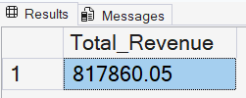

- Average Order Value
select Round(SUM(total_price) / count(distinct order_id),2) as Avrage_Order_Value from Pizza;
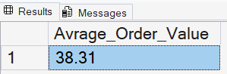

- Total Pizzas Sold
select SUM(quantity) as Total_Pizza_Sold from Pizza;
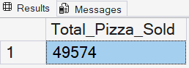

- Total Orders
select COUNT(distinct order_id) as Total_orders from Pizza;
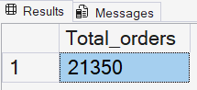

- Average Pizzas per order
select cast(cast(SUM(quantity) as decimal(10,2)) / cast(count(distinct order_id) as decimal (10,2)) as decimal (10,2)) as Average_Pizzas_Per_Order from Pizza;
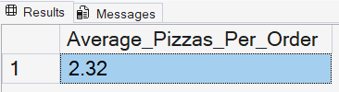

- Daily Trend for Total Orders
select DATENAME(DW,order_date) AS Order_Day,
COUNT(distinct order_id) as Total_Orders from Pizza
group by DATENAME(DW,order_date);
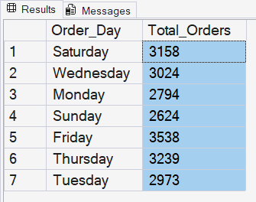

- Hourly Trend for Orders
select Datepart(HOUR,order_time) AS Order_Hours,
COUNT(distinct order_id) as Total_Orders from Pizza
group by DATEPART(Hour,order_time)
order by Datepart(HOUR,order_time) asc;
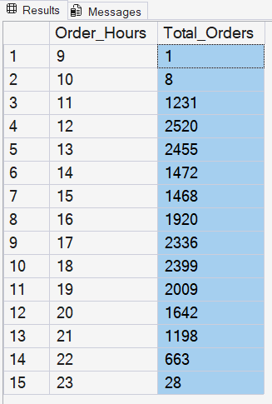

- % of Sales by Pizza Category

Select pizza_category,
Cast(SUM(total_price) as Decimal (10,2)) as Sales,
CAST(sum(total_price) * 100 / (select sum(total_price) from Pizza) as Decimal (10,2)) as PCT from Pizza
group by pizza_category;

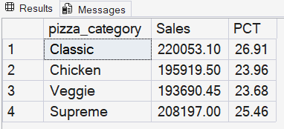

- % of Sales by Pizza Size
select pizza_size,
Cast(SUM(total_price) as Decimal (10,2)) as Sales,
CAST(sum(total_price) * 100 / (select sum(total_price) from Pizza) as Decimal (10,2)) as PCT from Pizza
group by pizza_size
order by pizza_size;

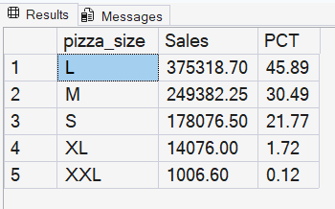

- Total Pizzas Sold by Pizza Category
Select pizza_category, sum(quantity) as Total_Quantity_Sold from Pizza
group by pizza_category;
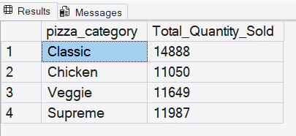

- Top 5 Best Sellers by Total Pizzas Sold
The TOP clause in SQL Server is used to limit the number or percentage of rows returned by a query.
select top 5 pizza_name,
sum(quantity) as Total_Quantity_Sold from Pizza
group by pizza_name
order by sum(quantity) desc;
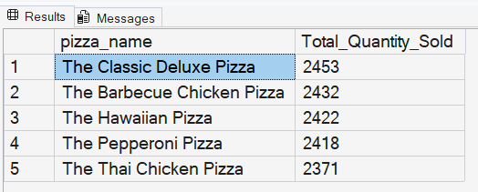
- Bottom 5 Best Sellers by Total Pizzas Sold
select top 5 pizza_name,
sum(quantity) as Total_Quantity_Sold from Pizza
group by pizza_name
order by sum(quantity) asc;
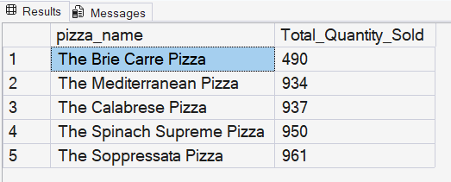

Note: Using Monthly, Weekly And Quarterly Filters to the Queries
select DATENAME(DW,order_date) AS Order_Day,
COUNT(distinct order_id) as Total_Orders from Pizza
where MONTH (order_date) = 1
group by DATENAME(DW,order_date);
- Month (order_date) = 1 indicates output of the January;
2 = February; 3 = March……………; 12 = December
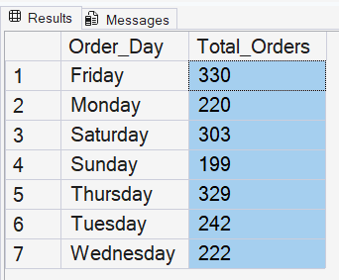
QUARTERLY
select DATENAME(DW,order_date) AS Order_Day,
COUNT(distinct order_id) as Total_Orders from Pizza
where Datepart (Quarter, order_date) = 1
group by DATENAME(DW,order_date);
- DATEPART(Quarter, order_date) = 1 indicates output of Quarter 1
2 = Quarter 2; 3 = Quarter 3; 4 = Quarter 4
